"The European Commission support for the production of this publication does not constitute an endorsement of the contents which reflects the views only of the authors, and the Commission cannot be held responsible for any use which may be made of the information contained therein."

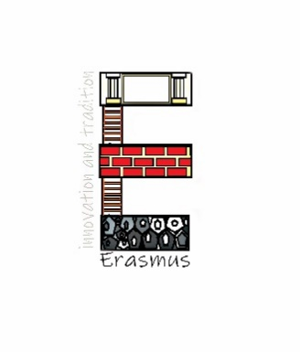FROM TRADITION

# TO INNOVATION

This year’s UNESCO topic was: From tradition to innovation. We worked with partners from Lithuania, Portugal, Poland and us, Czech Republic.

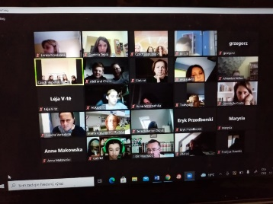The first half of our year was little bit boring, thanks to Covid. We started by choosing our logo. Everybody could vote online. Polish logo won.

Then we had an online meeting, where we were reading traditional fairy tales. It was fun. The European Day of Languages.

Next we continued by doing different homework’s, such as craft maps, our family jobs tree, essays etc.

After many never ending homework’s, we finally went on a trip. It was a trip on a local airport in Pardubice.

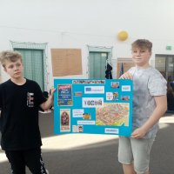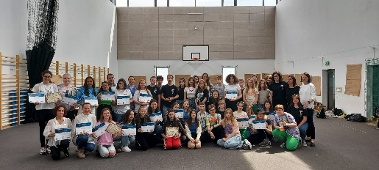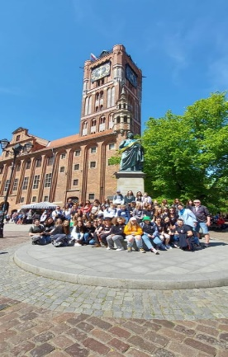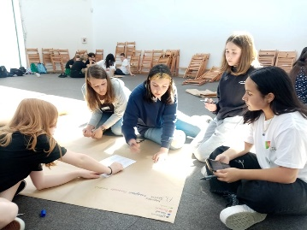On the start of a May, our school went to Poland. It was amazing, we lived with host families and travelled to many interesting places. We also did a collage about Poland.

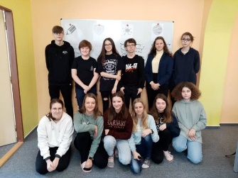When we came back from Poland, we went on another trip, to power station in Dlouhé Stráně. It was nice, but the wheatear was cold and windy.

First year of Erasmus was good, we are excited on the rest of our Erasmus project.